How GoodVision is rethinking Sustainable Development
With a simple solution, digital innovation, and local value creation, GoodVision enables access to education, employment, and economic participation for millions of people.
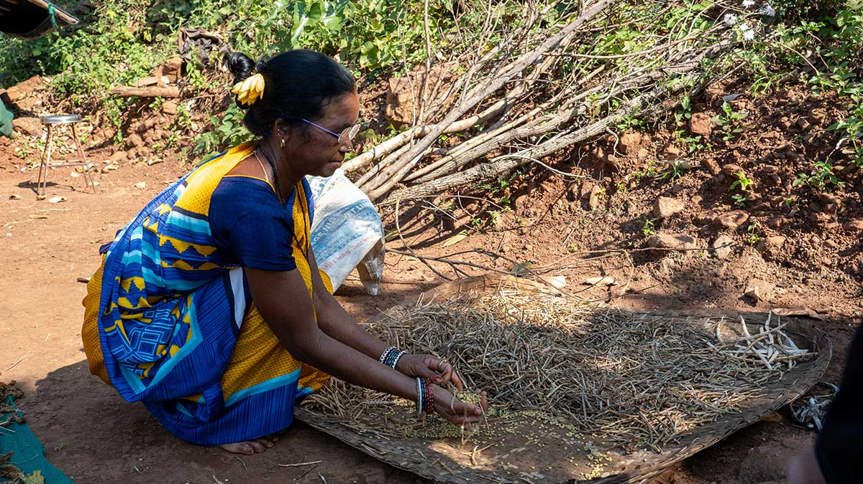
© GoodVision, An Indian farmer hand-sorting pulses (photo: Antje Christ)

Hamburg, June 2026 – What makes a sustainable business truly successful? Is it an environmentally friendly product, an innovative business model, or measurable social impact?
GoodVision’s answer is simple: all of the above.
As part of Hamburg Sustainability Week, the organization presents an approach that combines sustainable development with local value creation. At its core are affordable eyeglasses, the training of local specialists, and the establishment of long-term, sustainable eye care systems across Africa, Asia, and South America.
On 2 July 2026, GoodVision invites visitors to the Rittelmeyersaal (Heimhuderstraße 34a, Hamburg) from 5:00 p.m. onwards to experience its work firsthand. Guests can experience a simulated eye camp, observe the production of the glasses live, and gain insights into the GoodVision App. The presentation begins at 5:30 p.m.
According to the World Health Organization (WHO), around 950 million people worldwide live with a treatable visual impairment but lack access to basic optical care. The WHO identifies access to vision correction as a key driver of health, education, and economic development. Through its work, GoodVision contributes to the Sustainable Development Goals related to Good Health and Well-being (SDG 3), Quality Education (SDG 4), Decent Work and Economic Growth (SDG 8), and Reduced Inequalities (SDG 10).
“The barrier many African communities face is not a lack of drive or talent, but a lack of opportunities in healthcare and education. We bridge this gap by training local specialists and building sustainable infrastructure. This ensures that high-quality optical eye care is delivered locally and sustainably driven by the communities themselves.” – Alice Mwangi, Regional Coordinator Africa.
Good vision is far more than a health issue. It opens up opportunities for education, work, and social participation. A study by the International Agency for the Prevention of Blindness (IAPB) estimates that US$411 billion in global productivity is lost every year because people with visual impairments cannot work or are less productive – more than 90% of this loss occurs in countries in the Global South. Indirect costs also arise because children with visual impairments are more likely to drop out of school, and family members often have to support relatives with visual impairments, meaning they cannot work or can do so only with difficulty. Eyeglasses are therefore among the most effective investments in sustainable development.
This is exactly where GoodVision comes in. The specially developed glasses are a medical device certified in Germany. They are made from durable spring steel, individually fitted, and can be produced directly on site using a simple bending machine – without electricity, maintenance-free, and handcrafted. This not only creates access to affordable glasses but also lays the foundation for local production and value creation.
This approach is complemented by the newly developed GoodVision App. It supports vision testing, eyeglass dispensing, and follow-up care, works even without a permanent internet connection, and enables continuous patient support. At the same time, it contributes to quality assurance by standardizing and documenting treatment processes. Through the impact metric Vision Adjusted Life Years (VALY), the app also makes the benefits of eye care directly measurable.
Since 2012, GoodVision, with currently more than 500 employees in 11 project countries, has distributed over 1.1 million pairs of glasses and performed around 17,000 cataract surgeries.
“When I developed GoodVision Glasses, my goal was to provide as many people around the world as possible with glasses. Our teams make the glasses locally, travel to people in their villages, and provide them with the right pair. GoodVision builds sustainable structures for basic vision care – helping people help themselves.” – Martin Aufmuth, Founder and Inventor of EinDollarBrille (GoodVision Glasses).
Hamburg Sustainability Week provides the ideal setting to showcase this approach. Sustainable innovation is not only reflected in new technologies or climate-friendly products. It becomes visible where solutions create environmental benefits, economic viability, and social value at the same time.
GoodVision demonstrates how a simple idea can evolve into a scalable model with global impact – and why good vision remains one of the most underestimated prerequisites for sustainable development.
Sustainable Business Impact at a glance:
- Sustainable product: Robust and durable glasses, resource-efficient manufacturing, affordable access to vision aids
- Sustainable business model: Local organization in each country, training of local professionals, local production and value creation, long-term viable delivery structures
- Digital innovation: GoodVision App, data-driven service delivery, scalability even in rural regions
- Measurable social impact: Greater educational opportunities, higher employability, improved quality of life, contribution, among others, to SDGs 3, 4, 8, 10 and 17
-----
Note to editors: We are happy to arrange interviews. Images and further information are available on request. Please visit www.eindollarbrille.de/en
Presse contact: Vanessa Cognard, Leitung Kommunikation: presse@eindollarbrille.de , +49 (0)9131 913 94 31
Event Information: Renate Eden, fundraising@eindollarbrille.de, +49 (0)9131 927 85-22

About GoodVision / EinDollarBrille e.V.
Over 950 million people worldwide suffer from correctable refractive error, according to a WHO study, yet lack the means to purchase conventional eyeglasses. Against this backdrop, EinDollarBrille e.V. (GoodVision Germany) is committed to enabling global access to high-quality glasses that are affordable, robust, and individually fitted.
EinDollarBrille e.V. was founded in 2012 by Martin Aufmuth, the inventor of the EinDollarBrille, and is recognized as a non-profit organization. Training eyeglass producers and establishing the program in 11 countries across Africa, Asia, and South America are funded through donations. The project is sustainable: proceeds from the sale of glasses help cover the salaries of local professionals and the materials needed to make new glasses. Material costs for one pair are around one US dollar, while the selling price is two to three locally typical daily wages. This has dramatically reduced barriers to access for millions of people.
In addition, the organization advances the provision of ophthalmic examinations in remote and underserved regions, particularly cataract surgeries. Beyond training optical professionals, GoodVision also started to train specialized nurses. The goal is to ensure basic eye care and integrate it into public health systems in the program countries—so that early prevention, check-ups, and treatment are available to those in need.

