When We Lose What We Cannot See
At the art exhibition, “The Power of Time” (Die Macht der Zeit), GoodVision explores how access to vision care shapes opportunity, participation, and the way life unfolds.
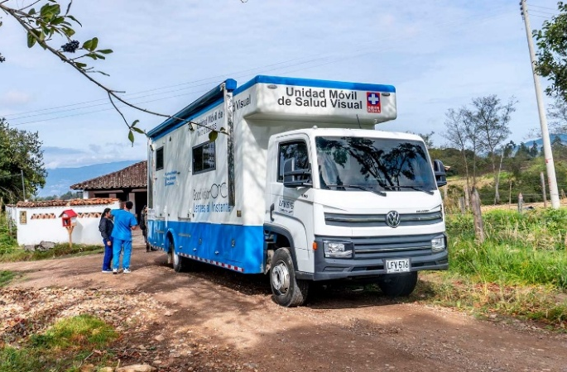 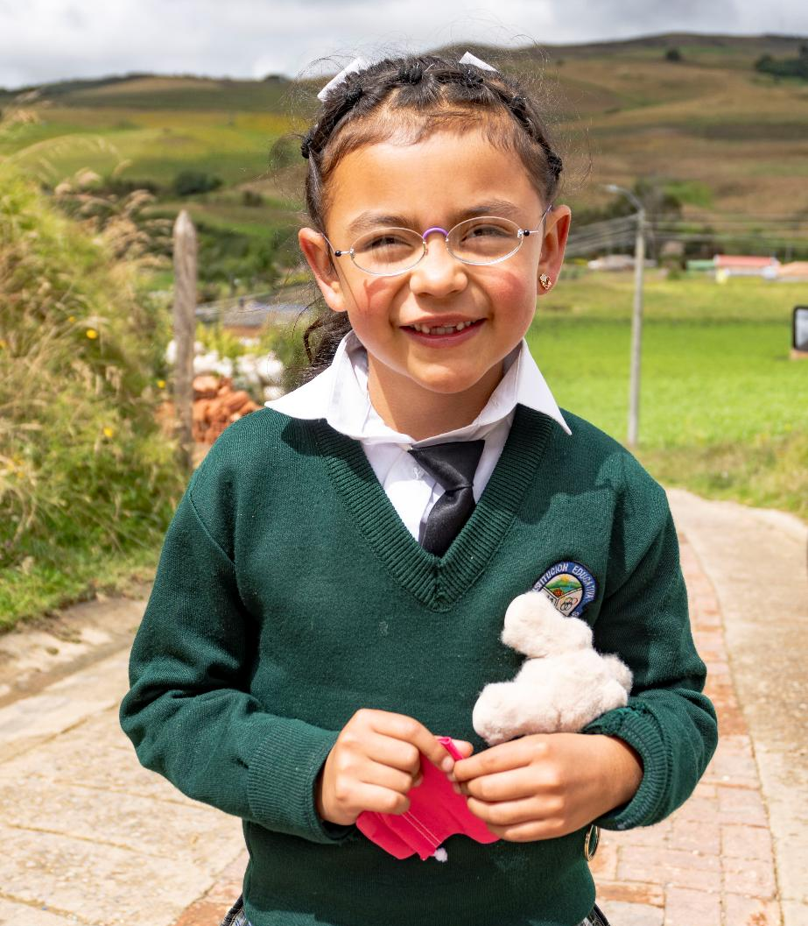 
©GoodVision Colombia
Nuremberg, July 2, 2026 – As part of “The Power of Time” exhibition at Nuremberg's Kongresshalle, GoodVision invites visitors to a special presentation on Saturday, July 11, at 1:00 p.m. Natalia Buitrago, Program Director of GoodVision Colombia, will share insights from her work in some of Colombia's most remote communities, from the Andes mountains to the Amazonian jungle, where access to vision care remains out of reach for many.
“The Power of Time” explores questions of dignity, freedom, and what it means to fully participate in life. Natalia Buitrago's presentation brings these themes into a global context, examining how access to vision care can influence education, employment, independence, and opportunity.
For millions of people around the world, poor vision is more than a health challenge. It can mean missed opportunities in school, barriers to employment, reduced independence, and fewer chances to participate fully in society. Over time, these losses accumulate, shaping not only what people can see, but what they are able to do, experience, and become.
Art Meets Human Experience
Art invites us to see the world differently. GoodVision works to ensure that everyone has the opportunity to see it. Together, the exhibition and presentation explore what it means to participate fully in life. And what may be lost when that opportunity is out of reach.
The exhibition explores questions of dignity and participation through art. Natalia Buitrago's work in Colombia offers a practical perspective on those same themes, illustrating how access to vision care can influence a person’s ability to learn, work, support a family and participate fully in their community.
Beyond a Health Issue
Poor vision is often treated as a medical problem, yet its impact reaches far beyond health. The presentation explores how barriers to vision care affect people's ability to learn, work, and participate in society, and how access can create new opportunities for individuals and communities.
Following the presentation, visitors will have the opportunity to engage with Natalia Buitrago and members of the GoodVision team in German, English, and Spanish. A live demonstration of the EinDollarBrille bending machine will complement the discussion, offering a hands-on example of how simple innovations can help expand access to vision care around the world.
Event Details
Date & Time: Saturday, July 11, 2026, at 1:00 p.m.
Location: Kongresshalle Nürnberg, Segment #16 (south side), Bayernstraße 100, 90478 Nuremberg, Germany
Admission: Free of charge
Note to Editors
The presentation is part of The Power of Time exhibition at Nuremberg's Kongresshalle. Following the presentation, visitors will have the opportunity to engage directly with Natalia Buitrago and members of the GoodVision team. A live demonstration of the EinDollarBrille bending machine will also be available.
Interviews, images, and additional background information are available upon request. Further information can be found at www.eindollarbrille.de.
Press contact:
Vanessa Cognard, Head of Communications, presse@eindollarbrille.de, +49 (0)9131 913 9431
About EinDollarBrille e.V. / GoodVision
Over 950 million people worldwide suffer from correctable refractive error, according to a WHO study, yet lack the means to purchase conventional eyeglasses. Against this backdrop, EinDollarBrille e.V. (GoodVision Germany) is committed to enabling global access to high-quality glasses that are affordable, robust, and individually fitted.
EinDollarBrille e.V. was founded in 2012 by Martin Aufmuth, the inventor of the EinDollarBrille, and is recognized as a non-profit organization. Training eyeglass producers and establishing the program in 11 countries across Africa, Asia, and South America are funded through donations. The project is sustainable: proceeds from the sale of glasses help cover the salaries of local professionals and the materials needed to make new glasses. Material costs for one pair are around one US dollar, while the selling price is two to three locally typical daily wages. This has dramatically reduced barriers to access for millions of people.
In addition, the organization advances the provision of ophthalmic examinations in remote and underserved regions, particularly cataract surgeries. Beyond training optical professionals, GoodVision also started to train specialized nurses. The goal is to ensure basic eye care and integrate it into public health systems in the program countries—so that early prevention, check-ups, and treatment are available to those in need.

