The glasses that taught an AI to see
At TDWI Munich, GoodVision shares how an AI project helped make a deliberately simple solution even more reliable — and how digital tools like the GoodVision App and VALY support the journey from care delivery to measurable impact.
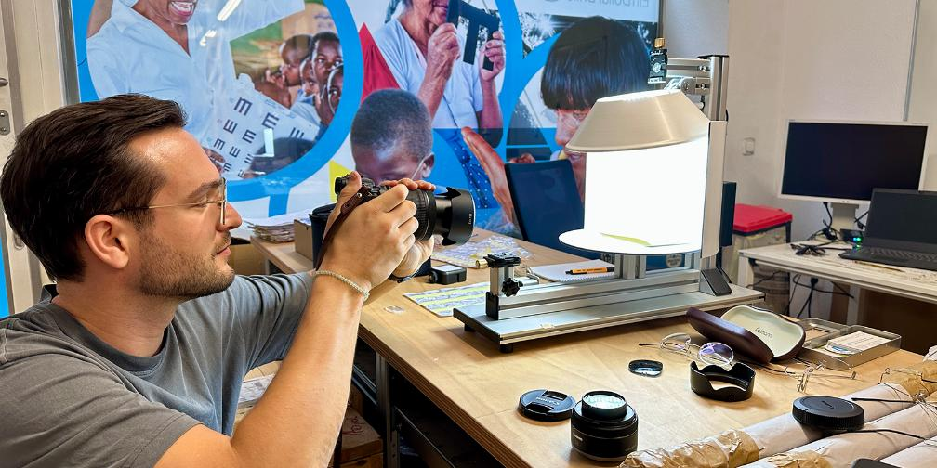
©GoodVision, Til Kerth during quality inspection in Erlangen (Photo: René von Künßberg)
Erlangen/Munich, 22 June 2026 — A pair of glasses made of spring steel wire, produced locally, without electricity, without expensive machinery. And at the other end, a neural network that can tell from a photo whether a temple arm has been bent correctly. Between these two worlds lies the real story that GoodVision is telling at TDWI Munich 2026: technology not as an end in itself, but as a quiet helper for a solution that is meant to stay simple.
In the talk “Computer Vision with Limited Resources: AI-Supported Quality Inspection in Eyewear Production” on Thursday, 25 June 2026 (9:00–9:45 am), Dr Niels Heller (QualityMinds, Tech Lead AI) and René Freiherr von Künßberg (GoodVision, Head of Optics) take the stage. They show how software can learn to spot quality defects from photos of glasses — and do so under anything but ideal conditions: few sample images, highly varied photos, and pictures that first had to be assessed and labelled by hand. Instead of a single piece of software judging everything at once, a dedicated, specialized program was developed for each inspection criterion. The surprising part: the large, all-purpose AI models performed worse here than the established, leaner methods. For one criterion, however, the software already achieved a detection rate close to practical use (in technical terms: an F1 score of 0.94).
Why quality is not a comfort topic here
Glasses are medical devices. They must fit precisely and work reliably — regardless of which program country they are made in. Because production is decentralized, the glasses are photographed, the images are sent to Germany, and they are inspected there by hand. It is a careful process that requires a trained eye and relies heavily on volunteer support. This is exactly where the pro-bono collaboration with QualityMinds came in: it analysed where computer vision can ease the inspector’s workload for recurring patterns — while making transparent where automation reaches its limits. The point is not to replace human expertise, but to support it where it makes the greatest difference.
From the inspection table to the field: a continuous idea
The project presented at TDWI is not an isolated case, but part of how the organization works systematically. At the IAPB congress “2030 IN SIGHT LIVE” in Nairobi (4–6 June 2026), GoodVision presented the GoodVision App to a global professional audience for the first time. It supports the diagnosis and care process in eye camps on a paperless basis and allows data to be captured directly on site. The use of NFC cards makes it possible to work reliably even without internet access. An algorithm checks the results for each prescription and immediately flags measurement errors or implausible entries for higher-level review. The app also integrates telerefraction, enabling extended consultations across long distances.
Embedded in it is VALY (Vision Adjusted Life Years), an innovative indicator developed by GoodVision. The idea: to make the impact of the work measurable beyond simply counting glasses. VALY measures the improvement in vision provided by a given visual aid — and for how long. It is calculated directly during the care process, individually and aggregated across patients, to make the impact of entire programs visible.
This creates a coherent arc of high-tech tools built around a brilliantly simple low-tech solution: computer vision in production, the app in patient care with integrated examination equipment — and VALY for impact measurement.
Of interest to people and companies driving technological change and asking unconventional questions
Anyone working on data quality and AI implementation will find parallels here for common challenges. For companies, the case study is relevant because it reflects typical realities:
- AI under real-world constraints: small datasets, variable image quality, limited labelling.
- Quality as responsibility: technology supports processes where reliability for people is at stake.
- End-to-end improvement of the value chain: from production (computer vision) through care delivery (the app) to impact (VALY) — see our press release from early June.
Far-reaching benefit: more than just technology
The collaboration between QualityMinds and GoodVision shows how technology can be applied deliberately to strengthen social projects. “For us, the focus is not on the technology, but on the concrete benefit for people on the ground,” emphasizes René von Künßberg, Head of Optics and Production at GoodVision. “With the support of QualityMinds, we can ease the load on our volunteer structures and at the same time keep improving the quality of our glasses.”
Outlook: sharpening the view together
The collaboration makes clear that responsible use of AI must always go hand in hand with a clear view of processes, data quality, and the human context. AI cannot and should not replace human expertise; it should support it precisely where it can have the greatest effect. The findings of the study mark not an endpoint, but a starting point. For GoodVision, one thing is clear: with improved data and step-by-step standardization, AI can make an even greater contribution in the future — and, in the long run, give more people access to good vision.
--------
Note to editors: We are happy to arrange interviews. Images and further information are available on request. Please visit www.eindollarbrille.de/en.
Details on the talk at TDWI 2026: TDWI Konferenz | Computer Vision mit knappen Ressourcen: KI-gestützte Qualitätsprüfung in der Brillenfertigung
Press contact: Vanessa Cognard, Head of Communications, presse@eindollarbrille.de,
+49 (0)9131 913 94 31

About EinDollarBrille e.V. / GoodVision
Over 950 million people worldwide suffer from correctable refractive error, according to a WHO study, yet lack the means to purchase conventional eyeglasses. Against this backdrop, EinDollarBrille e.V. (GoodVision Germany) is committed to enabling global access to high-quality glasses that are affordable, robust, and individually fitted.
EinDollarBrille e.V. was founded in 2012 by Martin Aufmuth, the inventor of the EinDollarBrille, and is recognized as a non-profit organization. Training eyeglass producers and establishing the program in 11 countries across Africa, Asia, and South America are funded through donations. The project is sustainable: proceeds from the sale of glasses help cover the salaries of local professionals and the materials needed to make new glasses. Material costs for one pair are around one US dollar, while the selling price is two to three locally typical daily wages. This has dramatically reduced barriers to access for millions of people.
In addition, the organization advances the provision of ophthalmic examinations in remote and underserved regions, particularly cataract surgeries. Beyond training optical professionals, GoodVision also started to train specialized nurses. The goal is to ensure basic eye care and integrate it into public health systems in the program countries—so that early prevention, check-ups, and treatment are available to those in need.

