Press Release

Simple and Effective: When Low-Tech Meets High-Tech
at the Deutsches Museum
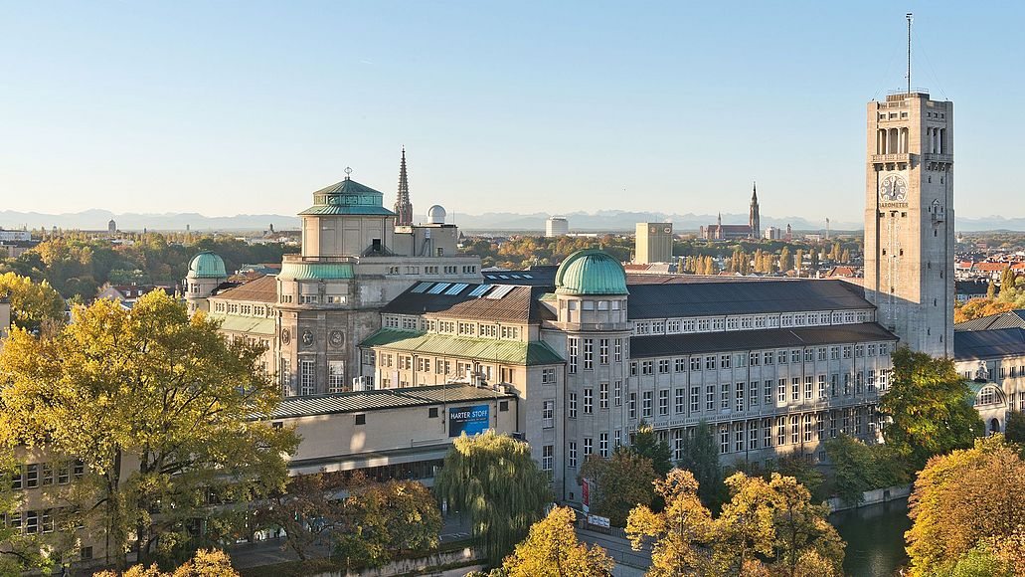
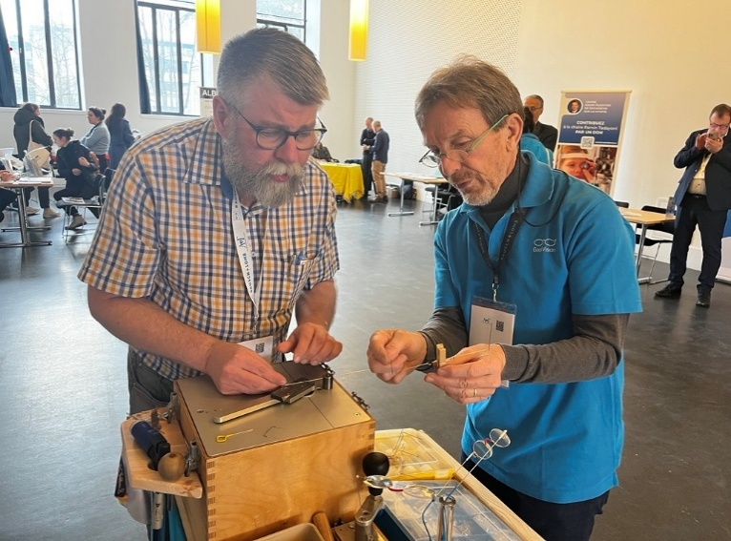
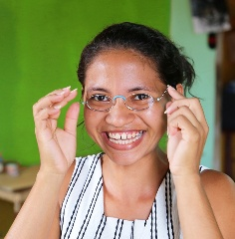
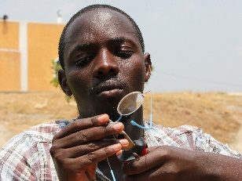
At the Science Communication Lab of the Deutsches Museum, EinDollarBrille will demonstrate how a simple idea is helping millions of people worldwide gain
access to professional eye care.
© Deutsches Museum, Foto von Reinhard Krause
Munich, March 25, 2026 – Combining low-tech and high-tech often leads to the most interesting solutions to some of the world’s most egregious problems. From April 4th to April 8th, 2026, EinDollarBrille will be featured at the Science Communication Lab (SCLab) of the Deutsches Museum in Munich. Visitors are invited to explore how a simple, well-designed idea currently enables millions of people globally to see clearly.
A Simple Solution with Global Impact
The EinDollarBrille, developed by German teacher Martin Aufmuth, is designed to be produced locally, without electricity or expensive machinery. Since the organization was founded in 2012, more than one million people have gained access to affordable eyeglasses through this novel approach. “Our goal is to address avoidable vision impairment with solutions that are as simple as they are effective,” says Aufmuth.
A High-Tech Space for a Low-Tech Idea
The Science Communication Lab at the Deutsches Museum offers a powerful space to share what drives our work. Surrounded by high-tech innovation, we highlight a simple truth: restoring vision does not have to be complex. Sometimes, real change begins with something as basic as a pair of glasses—and the chance to see the world clearly again. “Progress does not always have to be high-tech. EinDollarBrille shows how simple solutions can address global challenges in a very direct way,” says Judith Gabel, Head of the Science Communication Lab.
“EinDollarBrille reflects exactly what the Science Communication Lab stands for: making science accessible, tangible, and relevant for everyone. We are very pleased to host this initiative and share its approach with our visitors.”
Three Ways to Experience Our Work
At the Science Communication Lab, visitors can engage with EinDollarBrille through three interactive stations:
Station 1 – Be the One Giving Sight: Become a Vision Technician for a Day
Step inside an eye camp and see how trained GoodVision Technicians carry out vision screenings and provide affordable glasses within their own communities—often for the first time in a person’s life.
Station 2 – Simple Idea. Global Impact.
At our information stand, visitors can explore how a simple idea has grown into a global health innovation, now active in eleven countries. In a live demonstration, our team shows how a durable pair of glasses is made from spring steel wire using a small bending machine and simple hand tools—no electricity required. Material cost: around one US dollar.
Station 3 – The Craft of Vision: Handmaking a Pair of Glasses
Sit down, pick up the tools, and try it for yourself. What looks simple quickly reveals the precision and focus it takes to create a pair of glasses—functional, durable, and life-changing.
“We hope visitors not only discover the glasses themselves, but also understand the broader context, how simple, sustainable solutions can contribute to addressing global challenges.”
Connecting Vision Care and Sustainability
“For us, being part of the exhibit at the Deutsches Museum is an opportunity to introduce our work to a new audience,” says René von Künßberg, Head of Optics and Production at EinDollarBrille.
“We hope visitors not only discover the glasses themselves, but also understand the broader context, how simple, sustainable solutions can contribute to addressing global challenges.”
The adjacent special exhibition “Planetary Health – At the Pulse of People and Planet” creates a strong link to the topic of sustainable development. It highlights how closely human health and environmental systems are connected—and what happens when this balance is disrupted.
On April 7th, EinDollarBrille will host an evening event in the Lab and Auditorium. The program includes insights into the current ongoing work in the 11 EinDollarBrille program countries as well as a demonstration of the organization’s patient app, which now also includes tele-refraction. Participants can register directly with EinDollarBrille. Please register early as space is limited.
Media Invitation & Press Service
Members of the media are warmly invited to visit the exhibition and speak with the EinDollarBrille team. Interview opportunities can be arranged upon request. Images and additional information are also available on request. More information: www.eindollarbrille.de
Press Contact: Vanessa Cognard, Head of Communications, EinDollarBrille e.V.
presse@eindollarbrille.de
+49 9131 913 9431
www.eindollarbrille.de/en/press-area
www.linkedin.com/company/ein-dollar-brille

About EinDollarBrille e.V.
According to the World Health Organization, more than 950 million people worldwide live with uncorrected refractive errors but lack access to affordable eyeglasses. EinDollarBrille addresses this gap by providing high-quality, durable, and affordable glasses that can be produced locally. Founded in 2012 by Martin Aufmuth, the organization is recognized as a non-profit. The glasses are manufactured locally, with material costs of approximately one US dollar. The retail price corresponds to two to three days’ wages.Training for local producers and the establishment of programs are financed through donations. The model is designed to be sustainable: revenues from sales contribute to covering local salaries and materials.The long-term goal is to establish sustainable access to basic eye care services in underserved regions.
About the Science Communication Lab:
The Science Communication Lab at the Deutsches Museum in Munich fosters dialogue between science and society. It develops and tests new formats to make research accessible to a broad audience, including interactive workshops, presentations, and citizen science initiatives.Its work focuses on creating accessible, engaging formats that encourage exchange and improve understanding of complex topics. Learn more at: Science Communication Lab - Deutsches Museum

