Press Release

**GoodVision celebrates the delivery of its one millionth pair of glasses**

Franconian organization marks major milestone in its global mission against untreated defective vision

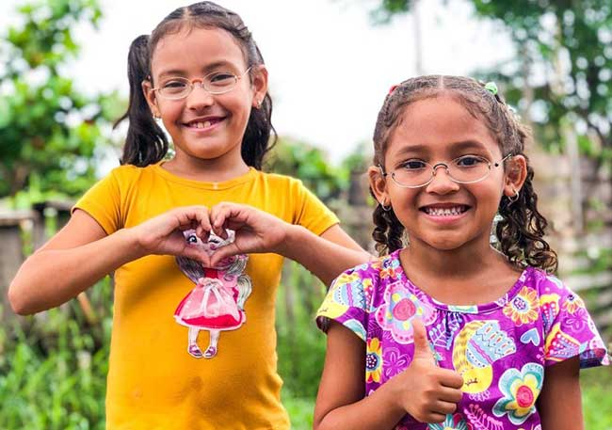

**Erlangen, September 2025** – **Good vision for all people. With this vision, Martin Aufmuth founded the association EinDollarBrille Germany (GoodVision) in 2012. His invention – a simple bending machine that produces durable eyeglasses locally, without the need for electricity all over the world – has profoundly transformed access to basic eye care in eleven countries. The glasses, made from flexible spring steel wire, cost about one US dollar in materials and are sold at a price equal to just two to three times the local daily wage. This sustainable model makes basic eye care affordable and accessible for people who previously had none. The result: Since its founding, the organization has distributed one million pairs of glasses worldwide. Today, GoodVision’s international work extends far beyond the manufacture of glasses, driving systemic change in eye health and opening new opportunities for millions of people.**

“One million pairs of glasses – that's one million people who can work, learn, read and participate in life again,” says Martin Aufmuth, founder of EinDollarBrille Germany. “Although we can't say exactly who received the millionth pair of glasses in which of our program countries, I still remember very well the person in Uganda who received our first pair of glasses over ten years ago. I will never forget his reaction – a pair of glasses changes everything.”

The distribution of one million pairs of glasses is not only a significant milestone for the Erlangen based EinDollarBrille, but it is also a significant step in fighting a truly global emergency. According to the World Health Organization (WHO), more than 950 million people worldwide need glasses but cannot afford them or do not have access to basic eye care. The consequences of poor vision are devastating and often have lifelong effects: children cannot learn properly, adults cannot work and provide for their families. With income losses amounting to US$269 billion per year, the consequences are equally serious for countries and their economies. This is where the mission of the EinDollarBrille comes into play: all people worldwide have permanent access to affordable and high-quality primary eyecare, especially glasses.

**A successful, impact-driven concept**

The association relies on an impact-driven concept that will continue to have a lasting influence on the society and healthcare system in each country. Beginning with its innovative bending machine, free eye tests, and educational outreach in schools and communities, EinDollarBrille (GoodVision) has expanded its efforts to include a comprehensive one-year training program for eye care professionals. Developed in collaboration with ophthalmologists and opticians, this program addresses the severe shortage of trained specialists faced by many countries and builds lasting local capacity for primary eye care.

Through its GoodVision Technicians (GVTs) program, EinDollarBrille (GoodVision) trains local specialists to provide reliable eye care. GVTs are equipped to dispense glasses with accurate prescriptions, identify eye diseases such as cataracts, and refer patients to medical specialists for further treatment. The success of this approach is evident: in 2024, Burkina Faso became the first country to officially recognize the training and integrate it into the national education system.

In addition, EinDollarBrille (GoodVision) trains local specialists in program countries to manufacture and distribute glasses, creating valuable jobs in underserved markets. The program places special emphasis on reaching rural communities and supporting individuals who face additional barriers – whether due to disability, gender or other disadvantages. In Burkina Faso, for example, the organization employs its first blind staff member, who works in eyeglass production.

**Internationally sought-after partner for eyecare**

In its SPECS 2030 Initiative, of which EinDollarBrille (Good Vision) is a co-founder and member, the WHO has strongly emphasized that access to basic eye care is a glaring global challenge that needs significantly more attention. The initiative seeks to expand eye care services for refractive errors by 40 percent by 2030 – a goal adopted by WHO member states as a global commitment to addressing the urgent need.

As a member of the International Agency for the Prevention of Blindness (IAPB) and in alignment with the United Nations' Sustainable Development Goals (SDGs), EinDollarBrille (GoodVision) is strongly positioned within international partnerships to advance its mission of “good vision for all people”.

**Service for editorial offices:**

You can download suitable images for your reporting [here](https://onedollarglasses-my.sharepoint.com/my?id=%2Fpersonal%2Fsusanne%5Fstocker%5Feindollarbrille%5Fde%2FDocuments%2FPressebilder%2FPressebilder&ga=1).

We would be happy to arrange interviews with founder Martin Aufmuth or the teams in our program countries.

For further information, please visit [GoodVision Germany](https://www.eindollarbrille.de/en) or [www.GoodVision.org](https://www.GoodVision.org).   
  
**Press contact:**  
**Susanne Stocker**  
Public relations  
E-Mail: [presse@eindollarbrille.de](mailto:presse@eindollarbrille.de)Phone: +49 9131 913 94 31

________

**About GoodVision (EinDollarBrille e.V. Germany)**

*According to a WHO study, over 950 million people worldwide suffer from correctable defective vision but do not have the means to buy conventional glasses. Against this backdrop, GoodVision (EinDollarBrille e.V. in Germany) aims to provide high-quality, affordable, robust and customized glasses worldwide. The organization was founded in 2012 by Martin Aufmuth, the inventor of the GoodVision Glasses (EinDollarBrille), and is recognized by the tax office as a non-profit organization. The GoodVision Glasses can be manufactured and sold by local people. The material costs for a pair of glasses are around one US dollar. The selling price is two to three local daily wages. The training of the producers and the development of the project in the target countries are financed by donations. The project is sustainable: the proceeds from the sale of the glasses help to cover salaries in the country and the materials for new glasses. The aim is to establish basic optical care for people in developing countries.*