GoodVision - people and their stories

As different as the life situations of our patients and employees are:
The OneDollarGlasses change their lives.
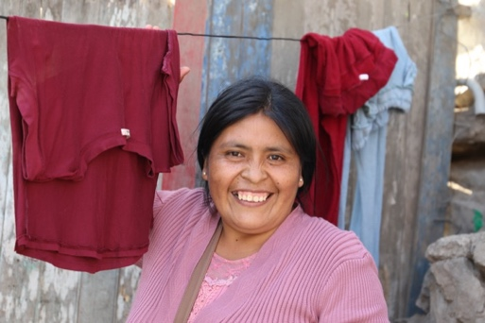 | Raquel, Peru  All of our eyewear producers have touching life stories. This includes Raquel, a Peruvian woman who previously peeled garlic with great difficulty to feed herself and her children on her meagre wages. At Lentes al Instante (Peru), the Peruvian partner of EinDollarBrille e.V., she enjoys two things above all: time for a family life and a secure job. Things used to be different. In order to be at work on time, she had to leave the house at dawn and not return until late in the evening. Our eyewear production facility is located in the middle of the Pueblos Jóvenes, the desert-like outskirts of Lima, where the producers live with their families and can be reached quickly. At the same time, we offer the women a protected place that allows them to work safely and with concentration. We see Raquel and her colleagues today as self-confident, satisfied and happy.  Raquel is part of the first all-female OneDollarGlasses production team and has been bending the frames for the program country Peru together with her colleagues since 2022.
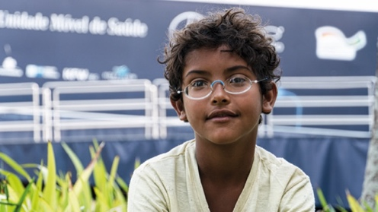 | Dener, Brazil  At the eye camp in a favela in Brazil, our team noticed eight-year-old Dener. The eye test showed that he had -11 diopters. Dener's mother lives with him and his brother in a small hut. They lack the most basic necessities and have never had the money for glasses. The boy was given a pair of glasses some time ago, but they were not the right strength.  When he saw his mother through the new OneDollarGlasses, he exclaimed in amazement: "So that's what you look like, mom - I only knew you had brown skin before."
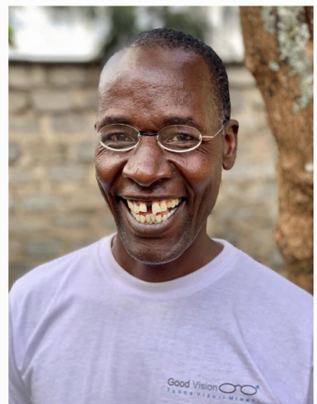 |  | Albert Ombati, Kenya  He was a gardener and employee at GoodVision (Kenya) in 2022 and also assisted at the eye camps. He has severe astigmatism in both eyes and has a visual acuity of just 20 percent without glasses. But with his OneDollarGlasses (corrected to -2.0 on both sides), he still achieves 80 percent.  With his OneDollarGlasses, Albert can now see so much better, even the clouds, which he always finds fascinating because they didn't exist for him before.
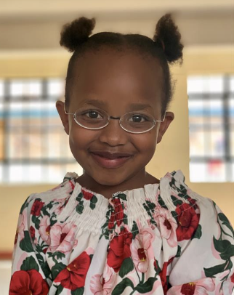 |  | Darlia Wanjiru, Kenya  Darlia Wanjiru is 9 years old and lives with her family in the Kawangware slum in Nairobi, Kenya. She came to the eye camp with her grandmother, who heard about it on a local radio station. Darlia had never worn glasses before. But her eyesight was so poor that she couldn't see everything at school, even in the front row.  During our eye test, it quickly became clear why: Darlia has a visual acuity of 15 percent without glasses, and she also suffers from severe astigmatism. With glasses with -3.0 diopters on both sides, she achieves a visual acuity of 80 percent. This was a huge improvement despite the severe astigmatism. For the first time in her life, she saw "properly" and sharply and swept through the room like a whirlwind, looking at everything and showing everyone her new glasses. A very special moment for our team.  To be on the safe side, we asked Darlia's grandmother to take her to an eye clinic, as the astigmatism is unusually high for her age. We also advised her to get Darlia glasses with a cylindrical correction if possible, as her vision is still developing at this age and a purely spherical correction is not the best solution in the long term.
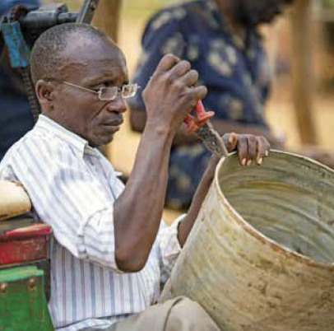 |  | Stephen Jackson, Malawi  Stephen Jackson is a tinsmith from Chingalu in Malawi. Every morning he sets off for work with his hand wheel. In recent years, he has found it increasingly difficult to carry out the delicate work safely because he could no longer see properly. When he heard that eye tests were being offered in the town, he set off straight away. The new OneDollarGlasses make everything much easier, he says, and gets straight back to work.
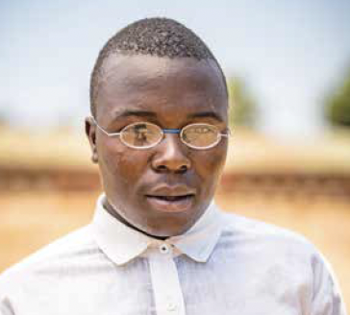 |  | Charles Osanka, Malawi  Charles is 17 years old and attends Ntchisi Secondary School in Malawi. In October 2022, we meet him there at an eye camp. He is delighted with his new OneDollarGlasses, which he desperately needs. Without his glasses, his eyes hurt and he couldn't read the writing on the blackboard properly: "My glasses are very important to me. I want to do well at school so that I can become a journalist later on.
Issaf Traoré, Burkina Faso
Issaf Traoré, now 60 years old, last wore glasses five years ago. At that time, he was still a chauffeur and with -3 dioptres, he was dependent on glasses. Now retired, his financial resources are no longer sufficient to replace his now unusable glasses. Issaf had almost come to terms with this when he discovered the GoodVision (Burkina Faso) office in his street. With his new OneDollarGlasses, Issaf can now walk the streets of Ouagadougou, the capital of Burkina Faso, safely and independently for the first time in five years. His colleagues at GoodVision (Burkina Faso) are delighted every time they see him walking past the office.

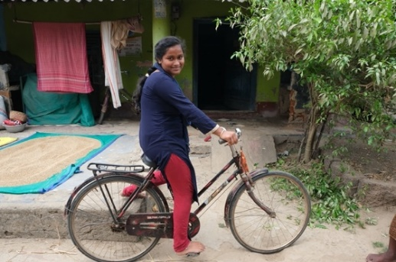 | Pankajini Pradhan, India  Pankajini Pradhan lives in the 1500-person village of Nimapada in Odisha, India. She underwent cataract surgery for the first time at the age of 14, and over the years her other eye also got worse and worse. Last year, the 18-year-old came to an eye camp run by Care Netram. Debasis - the head optometrist - urgently recommended that her parents have another operation at our partner clinic "Vision Eye Care Hospital" in Bhubaneswar. When we visited Pankajini a few months later for a check-up in her village, it turned out that her eyesight had improved significantly - for example, the young woman was able to ride her bicycle to school on her own again - but she still found it difficult to read. Debasis is able to convince the father to take his daughter to our new Vision Center, where she is thoroughly examined once again. Pankajini has astigmatism and needs reading glasses, which first have to be made. They will cost around 20 Euros - a big expense for the parents - but the father will try to raise the money somehow and Care Netram will also contribute. Pankajini still has so many years of life ahead of her. The operation and a good pair of glasses could change her whole life.
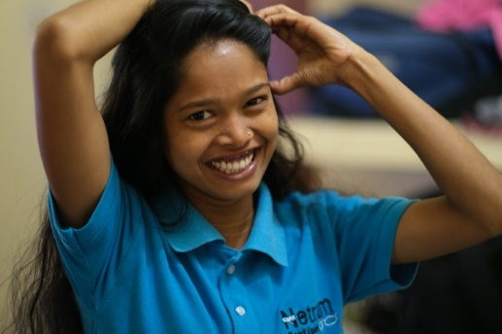 | Sweta Mahato, India  Sweta Mahato completed her training as a GoodVision Technician (GVT) at Care Netram in India in 2022. The 18-year-old has lived in the Asha Vihar orphanage in Jharkhand since she was two years old. The facility is part of the rehabilitation clinic, which is financed and operated by the German Johar Society and with which Care Netram cooperates. We have two rooms on the clinic premises for vision tests, the GVTs have their rooms there and receive meals. For Sweta, it is her home, but for the first time in her life she is earning her own money. However, she only keeps a small part of it for herself. She supports her siblings and her father, who live in a neighboring village. At the moment, Sweta is the only one in the family who has a regular income.

High-resolution images at presse@eindollarbrille.de

Contact
Annika Getto, Specialist Communications & Public Relations
E-Mail: presse@eindollarbrille.de

