Biography Martin Aufmuth

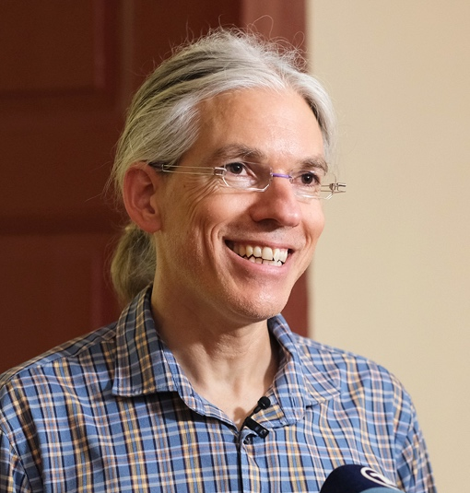
Martin Aufmuth is the founder and chairman of EinDollarBrille e.V. and was born on 13.04.1974 in Immenstadt in the Allgäu (Bavaria). From 1992 - 1995 he completed an apprenticeship as a radio and television mechanic, before studying mathematics and physics at the Friedrich-Alexander University in Erlangen to study mathematics and physics.

Until 2014, Aufmuth was a teacher for mathematics and physics at the Werner-von-Siemens secondary school in Erlangen. in Erlangen. During this time (2012), he founded EinDollarBrille e.V. Since 2014, he has been working full-time for the organization. For this work not only EinDollarBrille e.V., but also he personally has received several honored several times:

In May 2017, Aufmuth was officially accepted into the global circle of Ashoka Fellows worldwide. Ashoka
is the oldest and largest organization for the promotion of social entrepreneurs with headquarters in Washington. As Fellows, it only promotes social entrepreneurs who spread a new idea with a system-changing social impact. impact on society. In June 2017, Aufmuth was honored by Minister of State Emilia Müller awarded Aufmuth the Bavarian State Medal for Social merits was awarded.

Even before the founding of EinDollarBrille e.V., Aufmuth had already been involved in sensational projects to improving the living conditions of people in developing countries and for environmental environmental protection. With the "BallonMillion" campaign (www.ballonmillion.de) he initiated in June 2007 under the patronage of the former of the former Federal Minister for Family Affairs, Renate Schmidt, an online fundraising campaign for the organization "Das Hunger Projekt e.V.", which generated around 550,000 euros in donations.

His campaign "co2maus", launched in 2009, quickly became the largest climate protection climate protection competition for children and young people in Germany. So far around 45,000 children and young people together with their parents, siblings and and teachers have taken part in the campaign. This has saved around 40,000 tons of CO2 has been saved. In 2009, the project received the German Climate Prize from the Allianz Environmental Foundation and was recognized by the German government and the Council for Sustainable Development Council as a lighthouse project.

Contact
Annika Getto
Specialist Communications & Public Relations
E-Mail: presse@eindollarbrille.de

